**Step 1 : Observe the directory Before creation of container**

ls -l /var/lib/docker/containers/



**Step 2 : Deploy a Ubuntu server container**

docker run -i –t -d ubuntu:14.04 /bin/bash

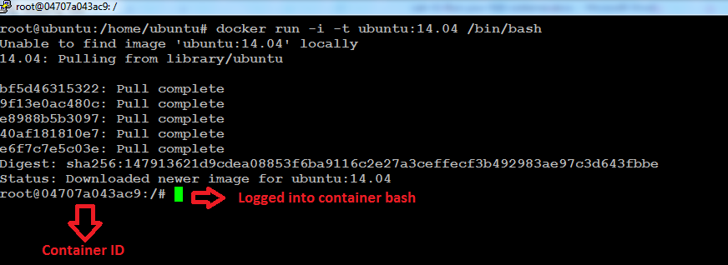

**Step 2.A : list the running container**

docker ps

**Step 2.b : Login to the container**

docker exec –it <containerid> /bin/bash

**Step 2.C : list process running in container**

root@04707a043ac9:/# ps -ef

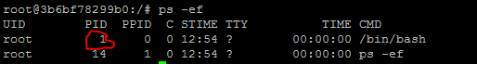

**Step 3 : exit from the container**

root@04707a043ac9:/# exit

**Step 4 : Observe the directory After creation of container on docker host login**

ls -l /var/lib/docker/containers/

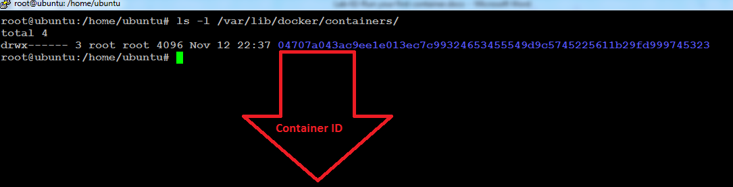

**Step 5 : Listing the Docker images**

docker images



**Step 6 : List the running containers**

docker ps



**Step 7 : Fetch info about container**

docker inspect 04707a043ac9

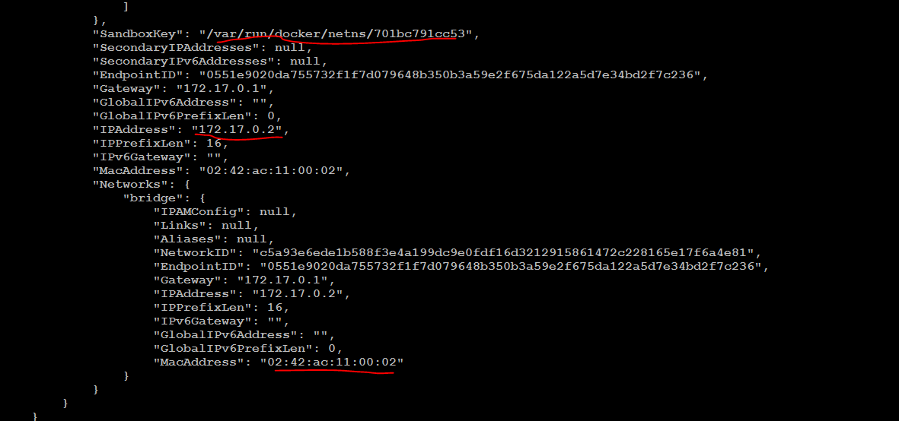

**Above info comes from**

/var/lib/docker/containers/0f4ea7ba2e814169377263918a9cb027f72f0295c45dc96f8661d0630501bc27/config.v2.json

**Step 8 : Login to your container**

docker exec -i -t 04707a043ac9 /bin/bash

**If you successful login you should be in your container bash login as below**

root@04707a043ac9:/#

**Step 9 : Validate your IP address of container**

root@04707a043ac9:/# ip a

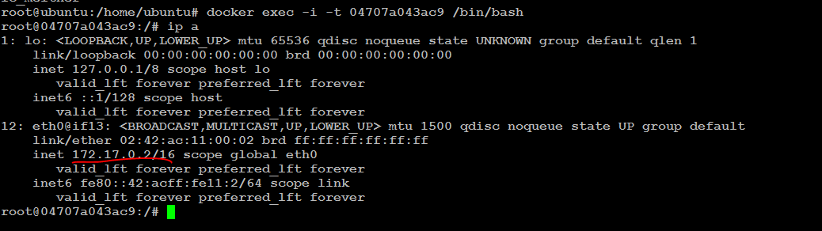

**Exiting the container**

root@04707a043ac9:/# exit

**Another way to shutdown ur container ( login as root on your host)**

docker inspect 3b6bf78299b0 | grep Pid



kill 4683

**You will notice container is stopped**

docker ps

